Fleet Methodist Church Pre-school – Curriculum Map 2025-2026

Autumn Term 1 | Autumn Term 2 | Spring Term 1 | Spring Term 2 | Summer Term 1 | Summer Term 2
Getting to know me | Changing Seasons and Celebrations | Rhyming stories | Our Planet and planting | Animals Big and small and life cycles | Summertime and moving on up!
This half term in Pre-school, we will be learning about Pre-school, developing friendships and people who help us in Pre-school.  We will get to know our families and become more aware and familiar with our feelings and our bodies and what makes us unique.  We will also be learning about Harvest and donating food to the food bank. As well as celebrating Diwali | This half term in Pre-school, we will be learning about changing seasons, weather, animals that hibernate and different woodland animals.  We will also be celebrating Christmas as well as learning about Firework Night and Remembrance Day.  We will finish by making you all something special for Christmas and have a special Sing along. | This half term in Pre-school, we will be learning about rhyming in stories. We will be enjoying a range of Julia Donaldson books, noticing the rhyming words.  We will look at story structure and sequence, do lots of reading and re-telling of some of our favourite books. | This half term in Pre-school we will be learning about the things that happen in Spring including growing our own plants.  Talking about sustainability and how we can help protect our planet for our future.  We will finish with an Easter Egg hunt! | This half term at Pre-School, we will be learning about the different sizes of animals, and how some change over time – looking in closer detail at the life cycle of a honeybee.  We will talk about the different types of bees, make our own bee hives, taste some honey and learn about the different uses of honey. | This half term in pre-school, we will be thinking about moving onto big school or staying in Pre-school and making new friends, where we might go on a day out or for our holiday.  We will finish with a special celebration for our school leavers.

 | Autumn Term  One | Autumn Term  Two | Spring Term  One | Spring Term  Two | Summer Term  One | Summer Term  Two
Main  Focus  Book | 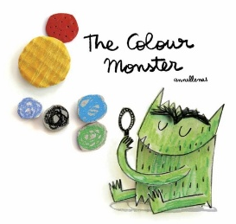  The Colour Monster  By Anna Llenas | 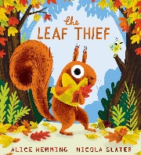  The Leaf Thief  By Alice Hemming & Nicola Slater | 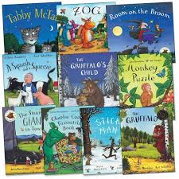  Julia Donaldson – Room on the Broom, Snail and the Whale, Gruffalo, Monkey Puzzle, Squash and a Squeeze, Stick man. | 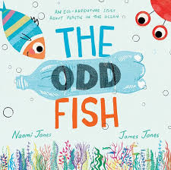  The odd Fish  By Naomi Jones and James Jones | 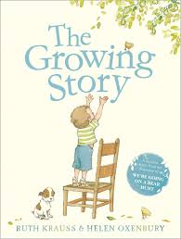  The Growing Story  By Ruth Krauss | 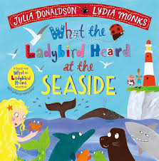  What the Ladybird Heard at the Seaside  By Julia Donaldson and Lydia Marks
Areas to focus on | Starting Pre-school and returning after the Summer.  Talking about feelings, having a sense of self. | Autumn and changing colours within the environment. | Exploring rhyming, creating our own rhyming string. | Protecting our planet and sustainability | Changes over time, growth and life cycles | How to stay safe in summer – hot weather, water safety  What we will do in summer
Additional books | Starting Nursery  Making Friends  Rubys Worry | Animals that hibernate  Leaf man  The little raindrop  Diwali  Christmas books | Other Julia Donaldson books | Recycling Fun (Peppa Pig)  Recycling  The Tiny Seed | Lifecycle books  Bee  Natures tiny miracle Bee | Starting school  Sharing a shell  The colour Monster goes to school
Focus song | If you’re happy and you know it  Dingle, dangle scarecrow | Weather Songs – The little raindrop, it’s raining its pouring. | Traditional Nursery Rhymes | This is the way we plant the seeds  I recycle | Old MacDonald  5 little speckled frogs  5 little ducks | 1,2,3,4,5  Row, row, row your boat

Autumn Term  One | Autumn Term  Two | Spring Term  One | Spring Term  Two | Summer Term  One | Summer Term  two
- 5th October – Harvest Festival  - 4th- 10th October World Space week  - 7th October – World Poetry Day  - 20th – 21st October - Diwali | - 5th November – Bonfire Night  - 11th November - Remembrance Day  - 13th November – World kindness Day  - 28th November - Thanksgiving  - Christmas & New Year | - 17th February – Chinese New Year  - 14th February – Valentines Day  - 17th February – Random Act of Kindness Day  - 17th February – Shrove Tuesday  - 17th – 18th March – Ramadan | - 1st March – St David’s Day  - 4th March – Shrove Tuesday  - 5th March – World Book Day  - 15th March – Mother’s Day  - 16th March – Holi (festival of colours)  - 17th March – St Patrick’s Day  - 20th March – Eid  - Easter | - 22nd April – Earth Day  - 23rd April – St George’s Day  - 20th May – World Bee Day  - 1st May – Vesak (Buddhism) | - 5th June – World Environment Day.  - 8th June – World Oceans Day  - 21st June – Father’s Day

